Project Design Phase-II
Data Flow Diagram & User Stories

Date | 15-07-2026
Team ID | SWTID-2026-3345
Project Name | BookVerse – Online Book Store
Maximum Marks | 4 Marks

Data Flow Diagrams:
A Data Flow Diagram (DFD) is a traditional visual representation of the information flows within a system. A neat and clear DFD can depict the right amount of the system requirement graphically. It shows how data enters and leaves the system, what changes the information, and where data is stored.
Simplified MERN Stack Data Process Flow:
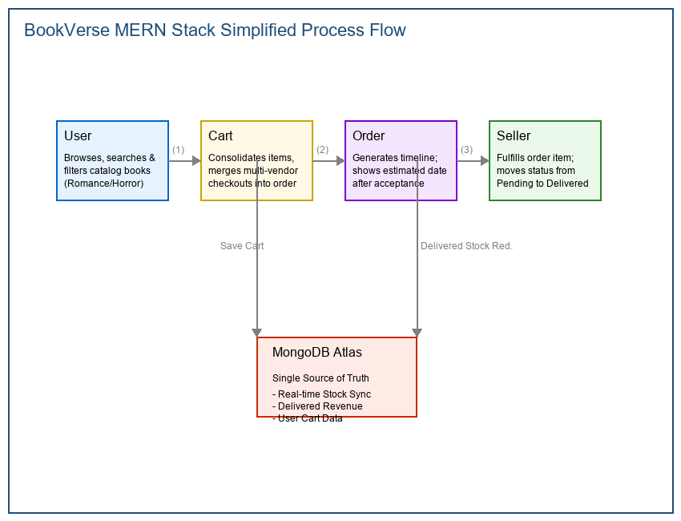
Figure 3.1: BookVerse Simplified MERN Data Process Flow
1. User logs into their account and browses the book catalog by categories (Biographies, Fiction, or Science).
2. User adds selected books to their cart, which dynamically updates item quantities.
3. Checkout page aggregates books from different sellers under a consolidated order summary.
4. The Seller views their orders dashboard, confirms the purchase, and updates the shipment status.
5. Once items are delivered, the system updates inventory stock levels and totals the seller's sales revenue.
Level-1 Data Flow Diagram (DFD):
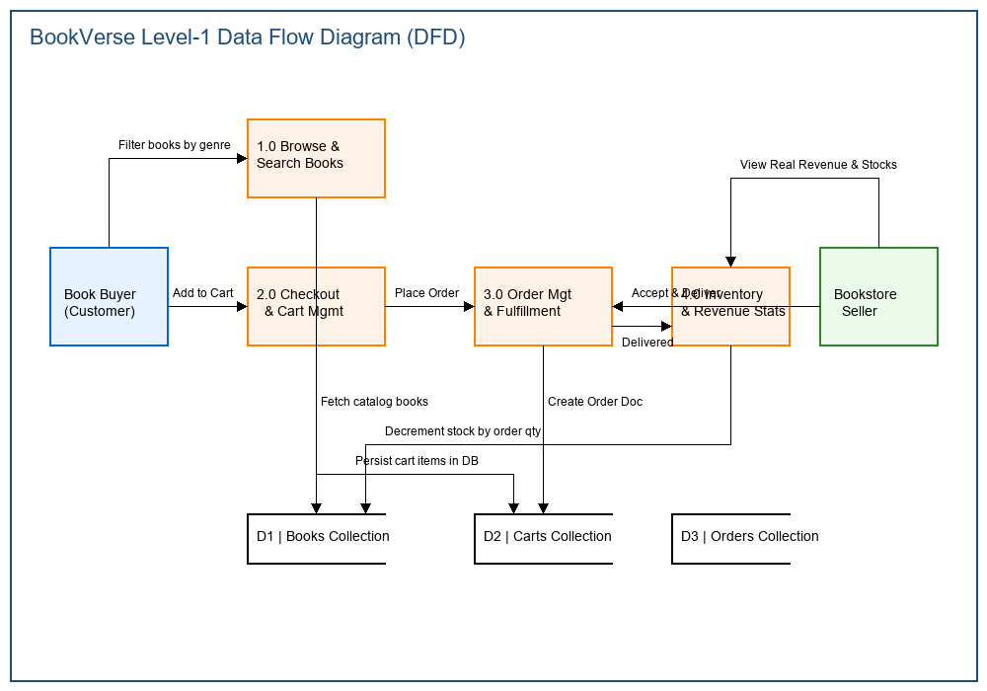
Figure 3.2: BookVerse Level-1 MERN System Data Flow Diagram

User Stories and Acceptance Criteria:
The following table documents the user stories, acceptance criteria, priority, and release sprint schedules for the different roles (Customer, Bookstore Seller, Administrator) in the BookVerse Online Book Store.
User Type | Functional  Requirement  (Epic) | User Story  Number | User Story / Task | Acceptance criteria | Priority | Release
User | Search &  Browse | USN-1 | As a user, I can search for books by title or author, and filter by categories like Biographies, Fiction, and Science. | Can view relevant search results and category-specific listings. | High | Sprint 1 – Core Development
User | Cart  Management | USN-2 | As a user, I can add books from multiple sellers to a unified cart and adjust item quantities before checkout. | Cart items and total price are calculated correctly on checkout. | High | Sprint 1 – Core Development
User | Checkout &  Timeline | USN-3 | As a user, I can place a consolidated order and see the tracking progress of my ordered books. | Tracking updates correctly when the seller accepts and ships the items. | High | Sprint 2 – Marketplace Features
Seller | Inventory  Management | USN-4 | As a seller, I can add, update, and delete books in my inventory, and see low stock warnings. | Book listing updates in real-time and displays low stock alerts. | High | Sprint 1 – Core Development
Seller | Fulfillment  & Stats | USN-5 | As a seller, I can accept orders, update delivery status, and view monthly sales stats. | Sales statistics and book stock quantities update when delivery is completed. | High | Sprint 2 – Marketplace Features
Administrator  (Admin) | Seller Control | USN-6 | As an admin, I can view all registered sellers and approve or block their store listings. | Only approved sellers can log in and manage their inventory; blocked sellers cannot access the platform. | Medium | Sprint 1 – Core Development
Administrator  (Admin) | Dynamic  Statistics | USN-7 | As an admin, I can view counters of all available books, registered sellers, and registered users. | Counters update correctly on the home landing page. | Medium | Sprint 2 – Marketplace Features

